
Q1) Identify the Data type for the Following:

Data | Data Type
 | (Continuous/Discrete)
Voltage | Continuous
Speed of the car | Continuous
Distance between planets | Continuous
The size of a two a bedroom flat | Discrete
Wind speed | Continuous
Face book likes | Discrete
Votes in election
 | Discrete
Make up kits purchased | Discrete
Death toll in flood disaster | Discrete
The waiting time of customers in bank | Discrete
Price of iPhone in the market | Continuous
Stolen Cars | Discrete


Q2) Identify the Measurement Level for the Following:

Data | Measurement level
 | (Nominal, Ordinal,
 | Interval, Ratio)
Size of egg | Ordinal
Monthly Income | Ratio
Unemployment rate | Interval
Military Rank | Ordinal
Shoe size | Interval
Pulse rate | Interval
Vital capacity | Interval
Favorite candy bar | Nominal
Name of the Grains | Nominal
Pesticides level | Ordinal
Tribe of origin | Nominal
Help Desk Service Satisfaction Score | Ordinal
Ethnicity | nominal
Marital status | nominal

© 2013 - 2020 360DigiTMG. All Rights Reserved.
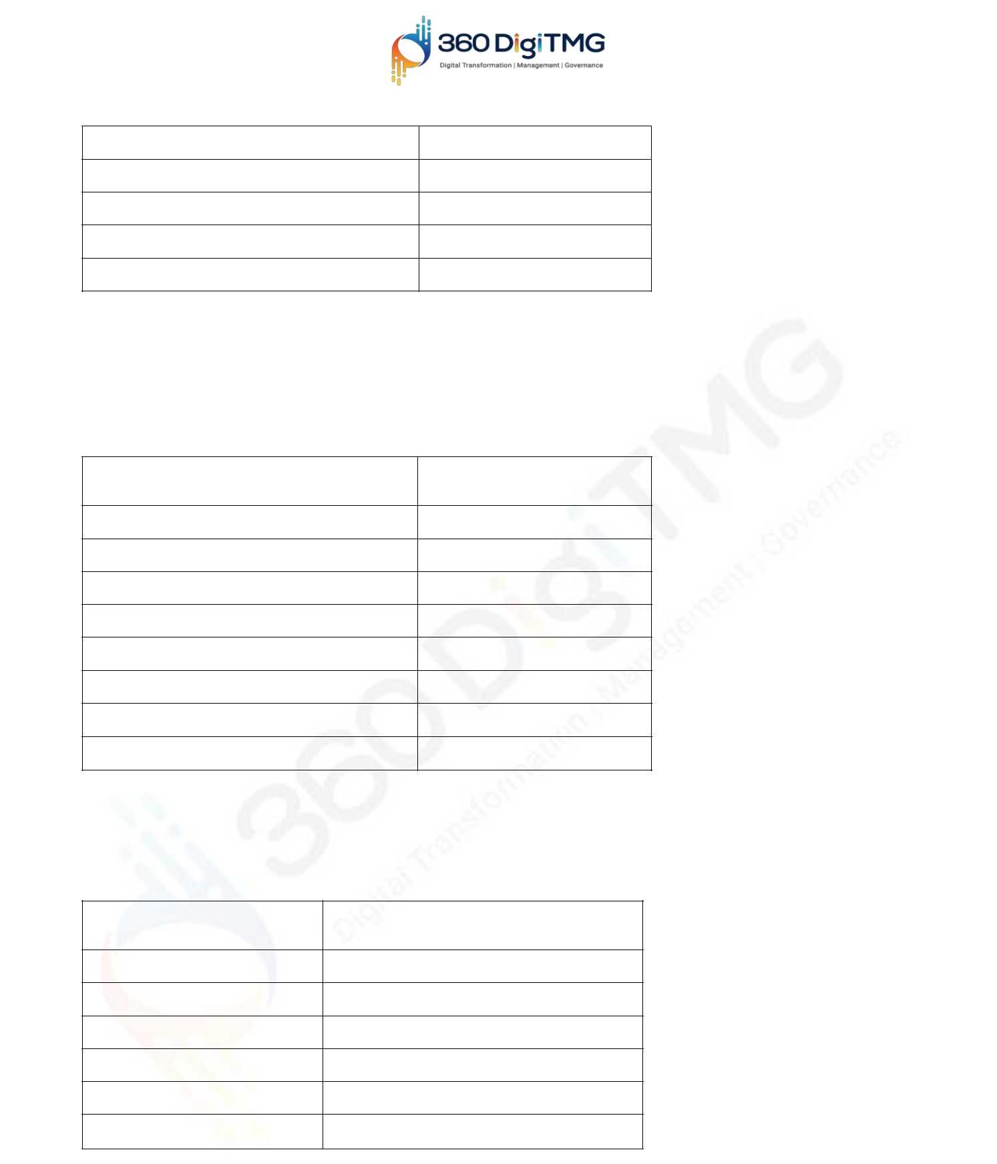
Type of Residence ordinal

Swimming level interval
Amount of Money Ratio

Colors of paint nominAL

Weekly Food spending Ratio

Q3) Identify whether the Data is Qualitative or Quantitative for the

Following:

Data

Data Type

(Qualitative/Quantitative)

I bought Strawberry lipstick today Qualitative

Happiness rating Quantitative

Duration of red-light signal Quantitative

I like butterscotch ice cream Qualitative

Setosa belongs to Iris family of flowers Qualitative

cold Coffee Qualitative

The Tea smells good Qualitative

Dress Size Quantitative

Q4) Identify whether the Data is Categorical or Numerical for the Following:

Data

Data Type
(Categorical / Numerical)

Product type Categorical

Native language Categorical

Type of teaching approach Categorical

Virus in a System Numerical

Covid-19 Positive Cases Numerical

Lockdown Days Numerical

© 2013 - 2020 360DigiTMG. All Rights Reserved.

Q5) Identify whether the Data is Structured or Unstructured for the

Following:


Data

Data Type
(Structured / Unstructured)

Credit card numbers Structured

Transaction information Structured

Text files Unstructured

Images Unstructured

Music files Unstructured

© 2013 - 2020 360DigiTMG. All Rights Reserved.

